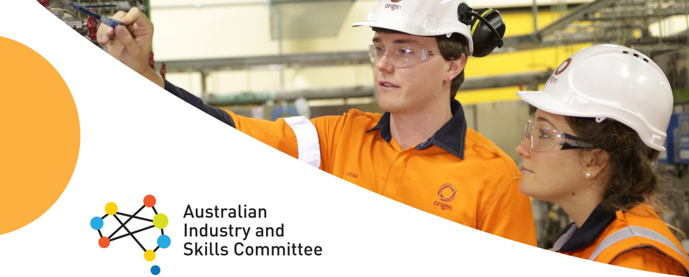

Drivers seat for industry in shaping skills

Businesses now have a greater say about the skills delivered in the vocational education and training (VET) system, thanks to reforms that put industry at the centre of training package development.
The new system gives industry a central decision-making role through the Australian Industry and Skills Committee (AISC), and its network of Industry Reference Committees (IRCs). These committees are made up of people with close links to industry, ensuring nationally recognised training packages are more responsive to businesses’ needs and the changing needs of the workplace.

The Australian Industry and Skills Committee
The AISC is an industry/government collaboration focused on:
- simplifying and demystifying the VET system
- amplifying the voice of industry in skills training development, and
- building employer’s confidence in VET qualifications.
AISC Factsheet – June 2017
The AISC is made up of industry leaders with links across the economy including in the construction, disability services, information technology, mining and hospitality and tourism sectors. The national peak industry bodies are also represented.
The AISC collaborates with other industry leaders, including through the Australian Government’s Industry Growth Centres (IGCs), and advises Commonwealth and State Skills Ministers to make sure that the voice of industry is heard.
The AISC is focused on ensuring Australian businesses have the workforce they need to be more innovative, productive and competitive, and to power our economy.
Industry Reference Committees
The AISC draws on advice from its network of over 60 IRCs. IRCs are made up of members who are leaders in their own sectors – from big business, small enterprises, peak bodies and unions.

IRC members have an in-depth knowledge of their industry and have a key role in making sure that training package qualifications meet the needs of the sector they represent. They work across their industry to ensure their advice reflects the needs of employers and the modern economy.
Skills Service Organisations
Skills Service Organisations (SSOs) are
independent professional service organisations that work on behalf of IRCs to consult widely with industry, prepare cases for change, and develop and revise training packages.
What is a training package?
Training packages are “skills standards” which set out the knowledge and skills and the standard of performance required to operate effectively in the workplace. They are used by Registered Training Organisations as the basis of their training offerings. Students who are assessed as competent against the standard set out in a training package are awarded a nationally recognised qualification. Training packages are set out on training.gov.au

Become involved
The voice of industry is critical to delivering quality and streamlined nationally recognised qualifications. Telling your IRC about your skills and training needs will ultimately make your business more competitive.
Contact your IRC through their SSO to find out about opportunities to become involved and to have your say on training packages for your sector. You can find out which SSO services your industry by visiting AISC.net.au
For more information visit aisc.net.au

Training package development – how the system works
Industry Reference Committees (IRCs)
Skills Service
Organisations (SSOs)
Australian Industry & Skills Committee (AISC)
Drives
Employers/ employees
(and their reps/peaks)
Industry advisory groups
(incl. Industry Growth Centres)
Governments
(incl. training authorities, licencing/regulatory bodies)
Training providers
Students
General public
Enable
Input to training package
develop -ment
For end users
Once endorsed by the AISC, training packages are available at www.training.gov.au

